[64. Minimum Path Sum](https://leetcode.com/problems/minimum-path-sum/description/)

Given a m x n grid filled with non-negative numbers, find a path from top left to bottom right, which minimizes the sum of all numbers along its path.

**Note:** You can only move either down or right at any point in time.

**Example 1:**

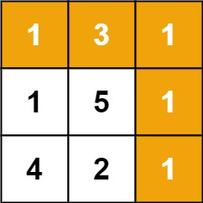

**Input:** grid = [[1,3,1],[1,5,1],[4,2,1]]

**Output:** 7

**Explanation:** Because the path 1 → 3 → 1 → 1 → 1 minimizes the sum.

**Example 2:**

**Input:** grid = [[1,2,3],[4,5,6]]

**Output:** 12

**Constraints:**

* m == grid.length
* n == grid[i].length
* 1 <= m, n <= 200
* 0 <= grid[i][j] <= 100